eBook Tutorial
- Is your virtual bookshelf that houses all of your eBooks while attending Stautzenberger College or Rockford Career College.

Creating Your VitalSource Bookshelf Account:
- Log into SuperMoodle using your Username (firstname.lastname@sctoday.edu) and the Password you created.
  - Click on a course.
  - The campus library coordinator is the on-campus support person for questions and problems related to eBooks.
- Hover the cursor over ebook title and click your left mouse button. You will be prompted to create an account. Fill in the appropriate text boxes with the information that is needed.
  - Use your school student email for the username. Do not use a personal email address.
  - When asked to create a Password, follow the instructions listed.
  - This is a one-time registration.
  - *IMPORTANT* Always use this combination from now on. If you are prompted to create a new username or password, ignore it and sign in with the combination you just created.
    - If you create a new account, you will not be able to see your books from the first account.
Vitalsource Bookshelf: Free App Available (download from your app store) 
- You will need to log in with your username and password.
- If you have downloaded your ebooks to the VitalSource Bookshelf app: After the first 9 days of your course the short term license will expire and you will not be able to see your ebooks when accessing the VitalSource Bookshelf through the app. You must activate the long-term license by logging back into SuperMoodle and opening the ebook in each of your courses. Once this is completed, you will then be able to see your books in the VitalSource Bookshelf again.
- Ebooks are a licensed product and will remain on your bookshelf for 1-2 years (depending on the publisher).
- Once a course ends the only way to view your ebook is to go through the Bookshelf app or Vitalsource.com
Pop-Up Blockers:
- Beware of POP-UP BLOCKERS – if, when you try to open your ebook, you get a message that your ebook has opened in another tab – but there isn’t another tab – there is a pop-up blocker.
- Chrome - look at the top right on the search bar and click on , then click on “always allow…” Then, click on the ebook link in the course again, and it will open properly.
- Internet Explorer – this information bar will appear at the bottom of your screen
Click on ‘Options for this site’ then choose ‘always allow.’ Click on the ebook link again to open it.
- Safari – Preferences / Security / uncheck the “block pop-up” box

Once you are logged into your eBook, the tools below will help you navigate through your eBook:
- Blue links do two things:
  - Link to another page
  - Define a word

- Functions of the Black Navigating bar running down the left side of your ebook page:
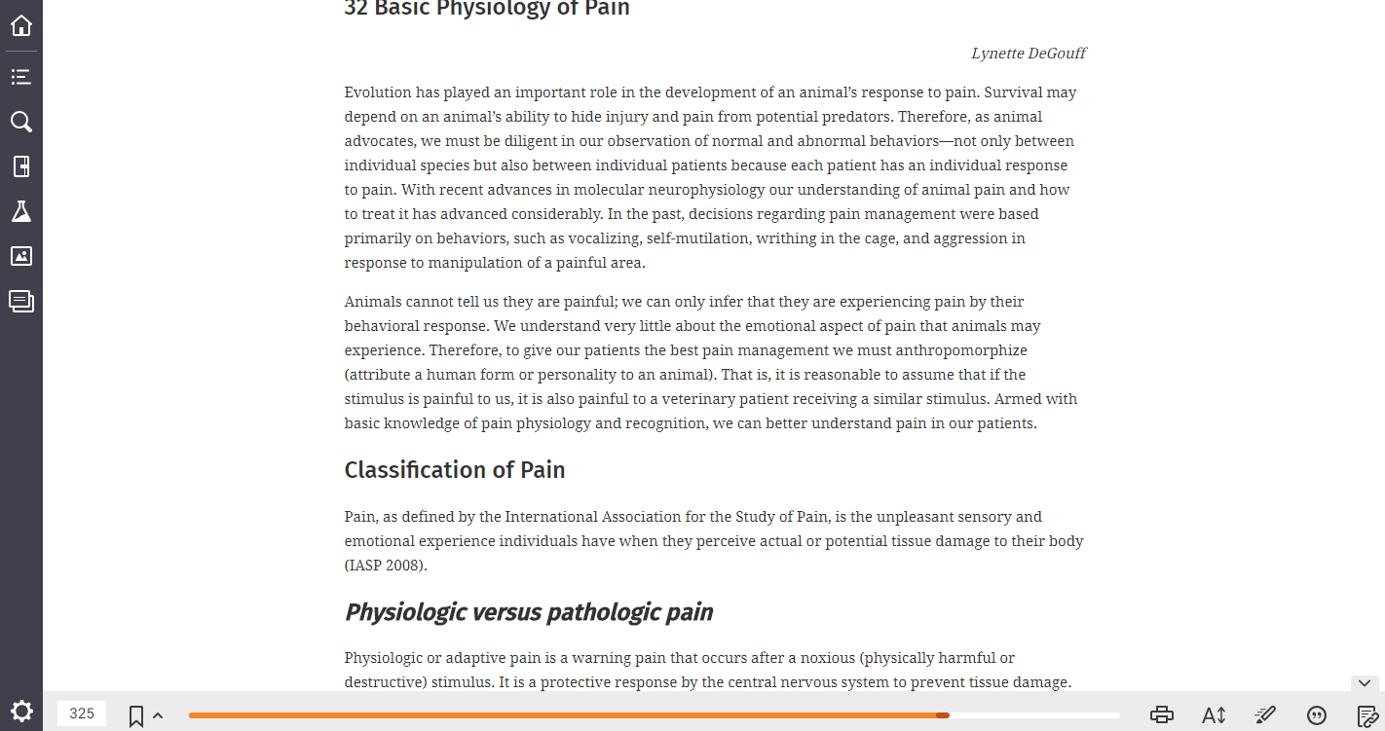

  - Home Icon (Library) 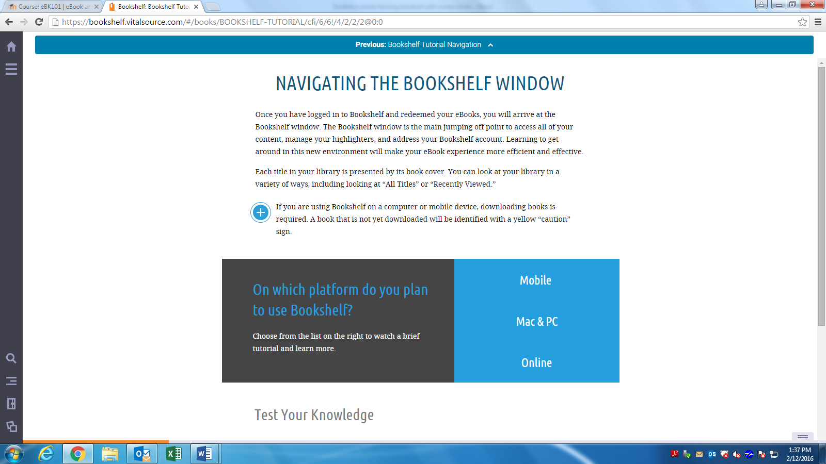
    - This takes you to your Bookshelf, where all your ebooks are located.

  - Table of Contents Icon
    - When selected, this feature appears on the left.
    - Use your left mouse button to click on any chapter or sub-heading.
    - Your textbook will update to the page where this chapter begins.
    - Close by clicking on the X in the upper left corner of the Table of Contents box.

  - Search Key Terms Icon
    - Use the left mouse button to click on the magnifying glass icon.
    - Enter the key term you would like to search for by keying it into the textbox.
    - Press enter on your keyboard.
    - A list of all instances where the key term is used will appear.
    - Use the mouse to left click on a specific highlighted key term, and your textbook will update to the page where this instance is found.
    - Close the Search box by clicking on the X in the upper left corner.

  - Notebook Icon
    - Shows all of your previously created highlighted texts and notes.
  - Labs Icon 
    - Labs are features in progress.

  - Figures Icon 
    - When selected, you can locate any figure or table from the book.
    - Close by clicking the X in the upper left corner.
  - Flashcards Icon 
    - Create flashcards based on the vocabulary in the ebook.

  - Settings Icon 
    - Access your account and device information.

- Functions of the Gray toolbar at the bottom of the textbook page on the monitor:

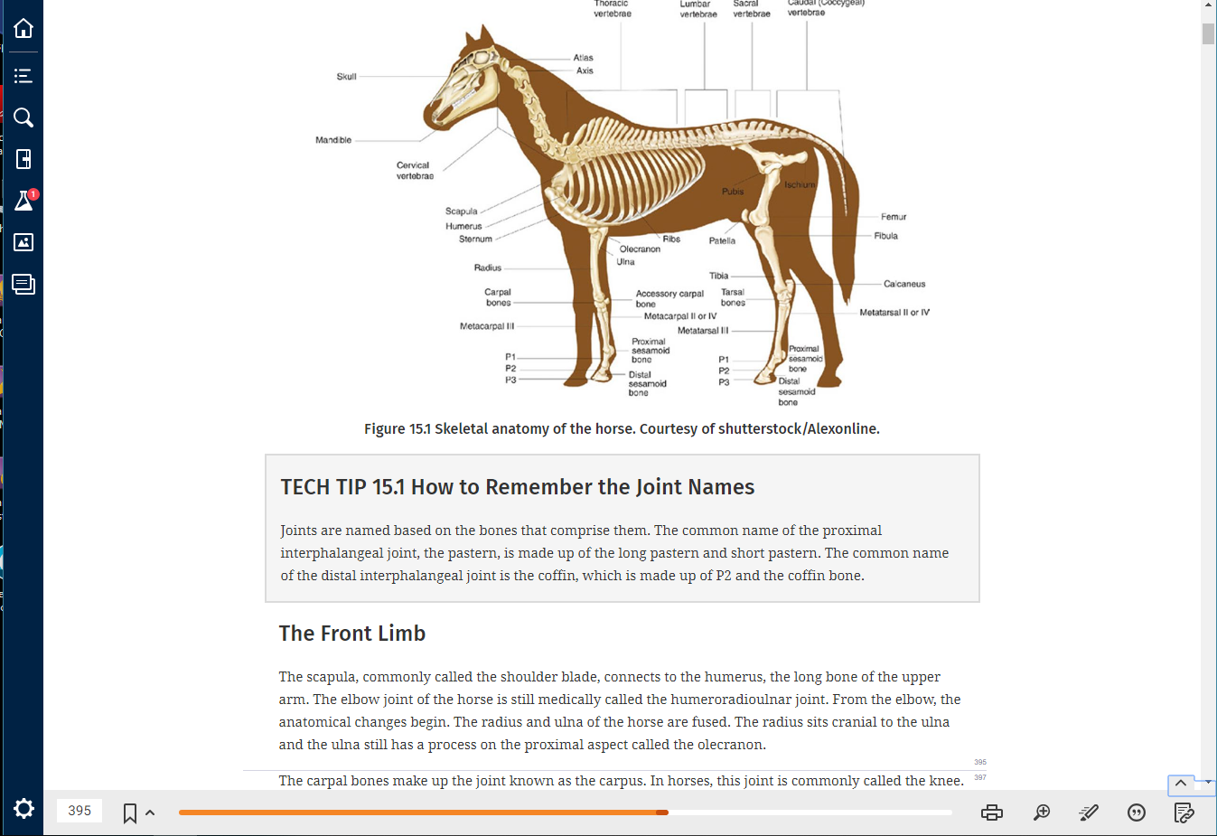

If you do not see this toolbar click on the small up arrow in the bottom right corner

  - “Go to page” box 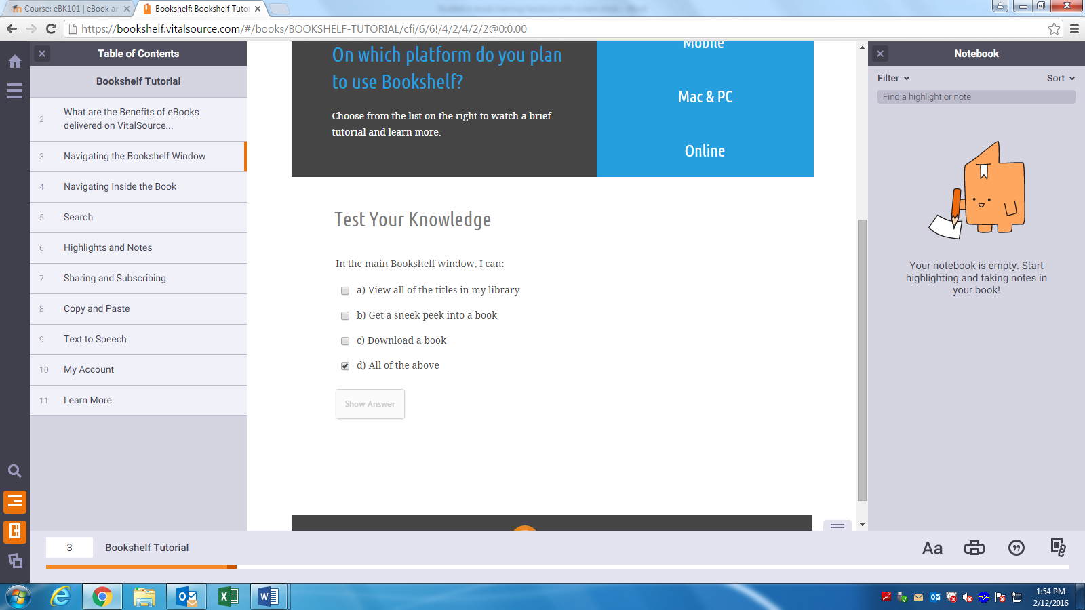
    - In the bottom left corner, you will see a text box. Type in any page number, hit enter, and the text on your screen will immediately move to this page in your textbook.
  - Printer icon
      - Use the mouse to left click on the printer icon to print selected pages of your book.
        - You will be limited as to how many pages you may print at a time. This feature is limited and set by the publisher of the book.
        - If the print preview comes up blank, try using a different internet browser (Chrome or Firefox work best).
  - Zoom Options - 
    - This button allows you to resize the ebook text.

  - Highlighting your textbook – 
    - Left click on the Highlighter icon
      - Fast highlight box will appear, left click on a color to activate.
      - Select text with your cursor, release mouse button, and text will be highlighted.
      - To deactivate fast highlight, left click on the icon again and click the X.
      - To delete a highlight, left click on highlighted text and a box will appear. Left click on the X.
    - Manual highlight and Add Note
      - Make sure “fast highlight” is not activated.
      - Select text to be highlighted.
      - A box will appear. Choose the color.
      - Here you can also select add a note which will show as a colored box on the right. Type your note, then click Save.
      - Edit Your notes
        - Use the mouse to left click on the box to see the full note.
        - Use the mouse to left click on the text to open the note to update or edit your personal comments.
        - Delete a note by left clicking on the X in the upper right corner.
      - To see all your notes and highlights, use your mouse to left click on the notebook icon which is found on the left.
      - Highlight, copy, and paste your notes into a Word document to print.

  - Cite your book
      - Use the mouse to left click on the citation icon.
        - Choose APA or MLA, then click copy. Paste the citation to a Word document.

